1. Ensure that you hold “Admin Rights” for respective VDI’s.
2. Also ensure you have approval for “TestAutomation(ClaimSphere)” as “Contributor” in

(<http://tpam.trizetto.com/>)

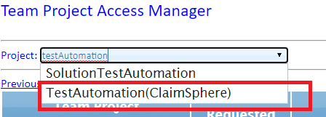

1. Install Eclipse from [\\abn-dev-file-11\drop\SQLStack\Members\QEA\Automation\Softwares](file:///\\abn-dev-file-11\drop\SQLStack\Members\QEA\Automation\Softwares)
2. Double click on Eclipse “eclipse-inst-win64.exe”
3. Select “Eclipse IDE for Enterprise java Developer” option

(If you are presented with a browser page stating “Thank you” instead of the flowing window, then install the “jdk-8u191-windows-x64.exe” file from the same path, and then repeat step 3)

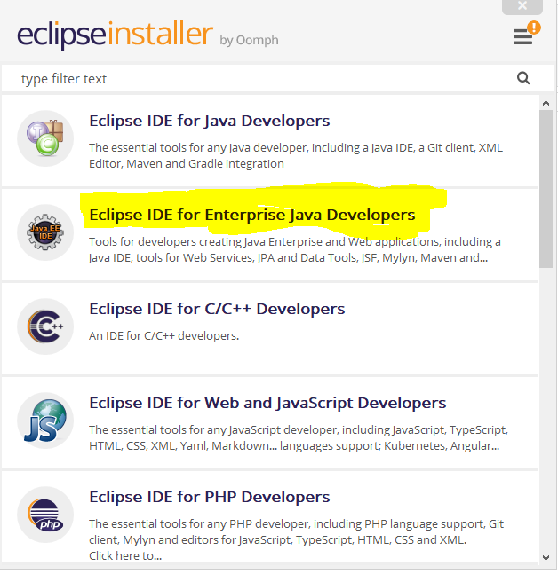

1. This well take time, Post installation click on “Launch” button.

(Accept any popup if presented)

1. Navigate to Help 🡪 Eclipse MarketPlace
   1. Search “TestNg” and install
      1. 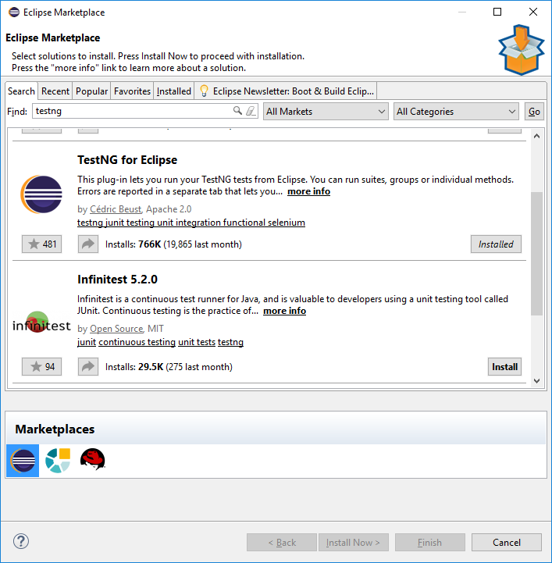
   2. Search “Cucumber” and install Natural 0.7.6
      1. 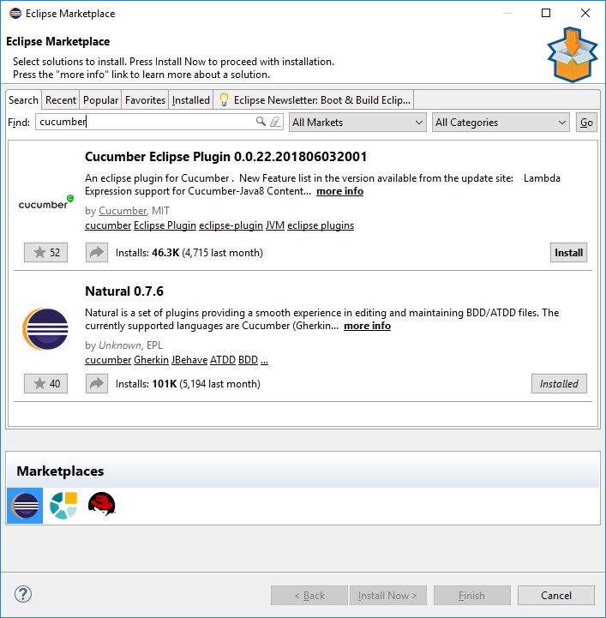
   3. Search TFS and install
      1. 